1 | Is there any inconsistency in the UI?    (The “Cancel” button is not active)
2 | Is there any inconsistency in the UI?  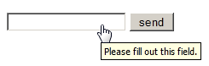  (There is no cursor in the field, the “send” button may be active when in text field are some symbols, the “send” button is not on the same line as text field)
3 | Is there any inconsistency in the UI?  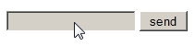  (The text field isn’t active, the “send” button is not on the same line as text field)
4 | How checkbox can be checked off?  (By pressing left button of mouse on checkbox, by pressing spacebar, when checkbox is on focus)
5 | The gender selection is implemented on screen below. Please describe the weak points of this implementation and propose better way of implementation.  (We must use the ratiobutton to choose just one of proposed variants)
6 | Please, propose improvements for the part of the screen below.  Requirement: if ‘no thanks’ checkbox is checked off other fields should be disabled  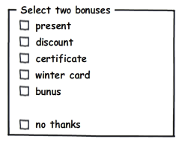  (The right writing is “bonus” on the five line, we must use comma between “no” and “thanks”, “no, thanks” must be directly under “bonus” checkbox)
7 | Please provide your recommendations regarding improvements of the part of screen below.  (First of all we must use ratiobuttons to choose one of variants, the second is that we must place variants on the column)
8 | Would a radio button be a better choice? (select between Portrait and Landscape mode, Portrait uses by default )  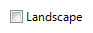  (No, if portrait mode is selected by default, we can use a checkbox)
9 | Is radio button the best choice?  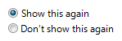  (Actually we must leave only the second sentence (“Don't show this again”) and use radio button)
10 | Is it the best implementation of the part of screen?  (We must organize all of the formatting types into column because such type of formatting is more readable)
11 | What is mixed-state for checkbox?  (It means that checkbox can be in a several states – checked, unchecked and mixed (square box in a checkbox))
12 | Can we use checkboxes as a progress indicator?  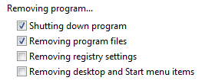  (Checkbox must be used only as instrument for checking some things. For a progress indicator we usually uses progress bar)
13 | Can we use the selection of a checkbox to perform commands?  (No)
14 | Can we use the selection of a checkbox to dynamically display other controls related to the selected control (screen readers cannot detect such events)?  (Yes)
15 | Can we use the selection of a checkbox to display other windows, such as a dialog box to gather more input?  (Yes)
16 | Are there any inconsistency in the relationship between radio buttons and checkboxes?  Requirement: when ‘Custom’ radio-button is selected all checkboxes are enabled.  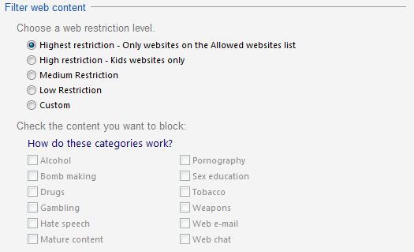  (When we select the first position - all of checkboxes must be enabled)
17 | Is it the best implementation of screen?  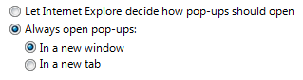  (This implementation is acceptable)
18 | How implementation of screen can be improved?  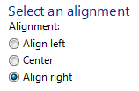  (The best implementation will be when we take off all of the second line (“Alignment”), and the “Align” word in first and third radio-button)
19 | Is it the best way of the controls’ location on the screen?  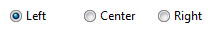
20 | Is it right to leave editable text boxes and drop-down lists enabled if they share the radio button's label? (See example). What requirement should be for the editable field?  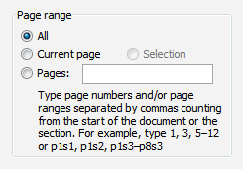  (We can leave the editable text boxes. On editable field we can input information only when “Pages” radio-button is enabled)
21 | What is list-box, c, combobox? What are the two types of combobox?  (List-box allows user to select some item('s) from a list. Drop-down list is an element that allow user to choose one item from a list. There are a simple combo box and a drop-down list box)
22 | There are numbers from 1 to 31 (day of month) in dropdown list. How we can select 5?  (We can select 5 using left button of mouse to open a dropdown list and click on 5; Also we can focus a dropdown list using a Tab-button, and press 5 on a keyboard)
23 | There are numbers from 1 to 31 (day of month) in dropdown list. How we can change selection between 3, 30, 31 items?  (We can press a Control-button on a keyboard and use a left mouse button or a combination of an arrow-keys and a spacebar button)

